For more information: Press Releases
JBL Greece ( Official Distributor WaveMotion S.A) For direct publication.
Τηλ.:210-9244505 Date:
Email: jbl_greece@wavemotion.gr
JBL and Kotsovolos travel you
to the biggest party ever, in Alps.

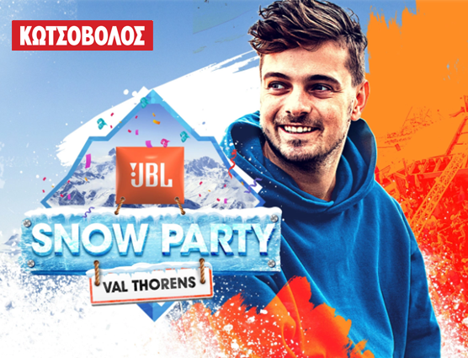

JBL Snow Party returns with the top electro dance dj in the world, Martin Garrix!

Three days. One ski resort. Epic live performances.
Shop JBL from Kotsovolos for a chance to win tickets for the biggest party ever in Alps.

JBL Greece (Official Distributor WaveMotion S.A.), introduces the beginning of a great Giveaway for the buyers of JBL products. Purchasing a JBL product from Kotsovolos stores or online in Greece and Cyprus, customers will have a chance to win tickets for the biggest ever party in the Alps.

The favorite brand that produces products with Original JBL Pro Sound, decides to give a chance to its fans to live the ultimate Experience.
The contest period starts on January 27th, 2022 and ends the xxxxx. In order to qualify for a chance to win a prize, participants must: buy a JBL product exclusively from Kotsovolos in Greece or Kotsovolos in Cyprus, register on https://eu.jbl.com/snowparty-2022-gr.html during the promotion period, and provide their name, email address, a phone number where they can be reached, the product they bought, the store they bought it from, the date of purchase, the number of the receipt and agree to the promotion’s terms and conditions.
Win tickets to the biggest ever party in the Alps.

Shop JBL from Kotsovolos in Greece or Kotsovolos in Cyprus!

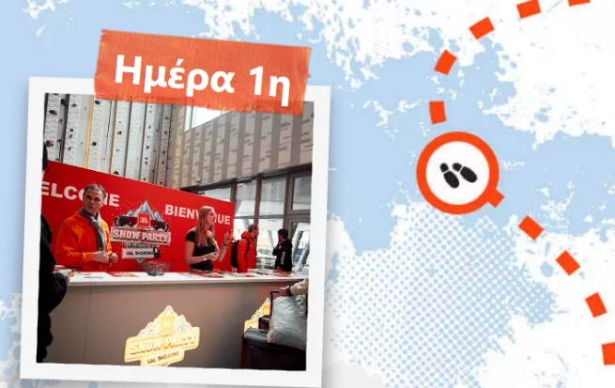
Welcome Party at Club Med
Travel in style to Val Thorens, France and check in at the luxe Club Med hotel. Grab a welcome drink and dinner before the party kicks off

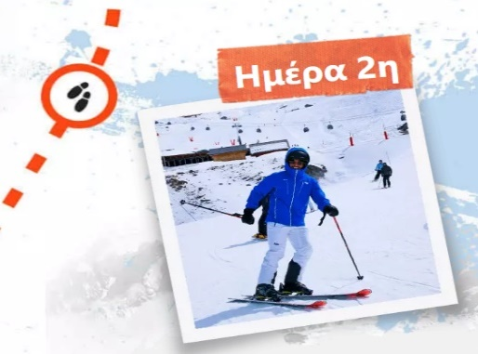
Spend the day skiing, boarding or chilling before the après ski festivities commence. After dinner, join us at JBL Club Party.

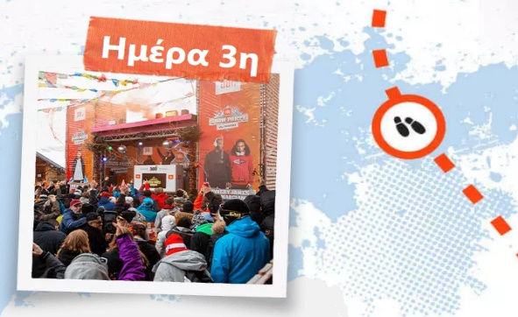

Enjoy another day on the slopes ahead of a night of incredible beats. Join us at JBL Altitude Party, then keep dancing at our Après Ski Party

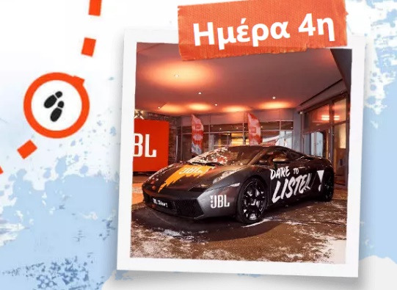
Relax at the hotel before heading home to recover. Take home amazing memories and epic pics for your socials

Get ready for the biggest ever party in the Alps with JBL and Μartin Garrix!

Discover more at:
Home | JBL (jblgreece.gr)
 @jbl_greece
JBL Greece

About WaveMotion
WaveMotion, an importer and distributor, is seated in Athens Greece, operating on a wholesale basis, in the consumer electronics, telecommunications and computer industry for over 35 years. WaveMotion S.A. retains the official, exclusive, distribution for the Greek market of important Houses- in leading positions in the Global Arena, like JBL, harman/kardon, Cambridge Audio, Q Acoustics, QED, Goldring, rapoo, Native Union, Livall. Brand Development is the core skill of WaveMotion Team. The vision of our people is to expand WaveMotion’s Brands selection, following our tagline’s principles –Technology, Aesthetics, Design- and continue this journey of Ours, introducing compellingly and establishing decisively these Brands, in the eyes of our Customers.

About HARMAN
HARMAN (harman.com) designs and engineers connected products and solutions for automakers, consumers, and enterprises worldwide, including connected car systems, audio and visual products, enterprise automation solutions; and services supporting the Internet of Things. With leading brands including AKG®, Harman Kardon®, Infinity®, JBL®, Lexicon®, Mark Levinson® and Revel®, HARMAN is admired by audiophiles, musicians and the entertainment venues where they perform around the world. More than 50 million automobiles on the road today are equipped with HARMAN audio and connected car systems. Our software services power billions of mobile devices and systems that are connected, integrated and secure across all platforms, from work and home to car and mobile. HARMAN has a workforce of approximately 30,000 people across the Americas, Europe, and Asia. In March 2017, HARMAN became a wholly-owned subsidiary of Samsung Electronics Co., Ltd..

