For more information: Press Release
JBL Greece ( Official Distributor WaveMotion S.A) For direct publication.
Tel.:210-9244505 Date:26/3/25
Email: jbl_greece@wavemotion.gr

New Partybox Encore 2!
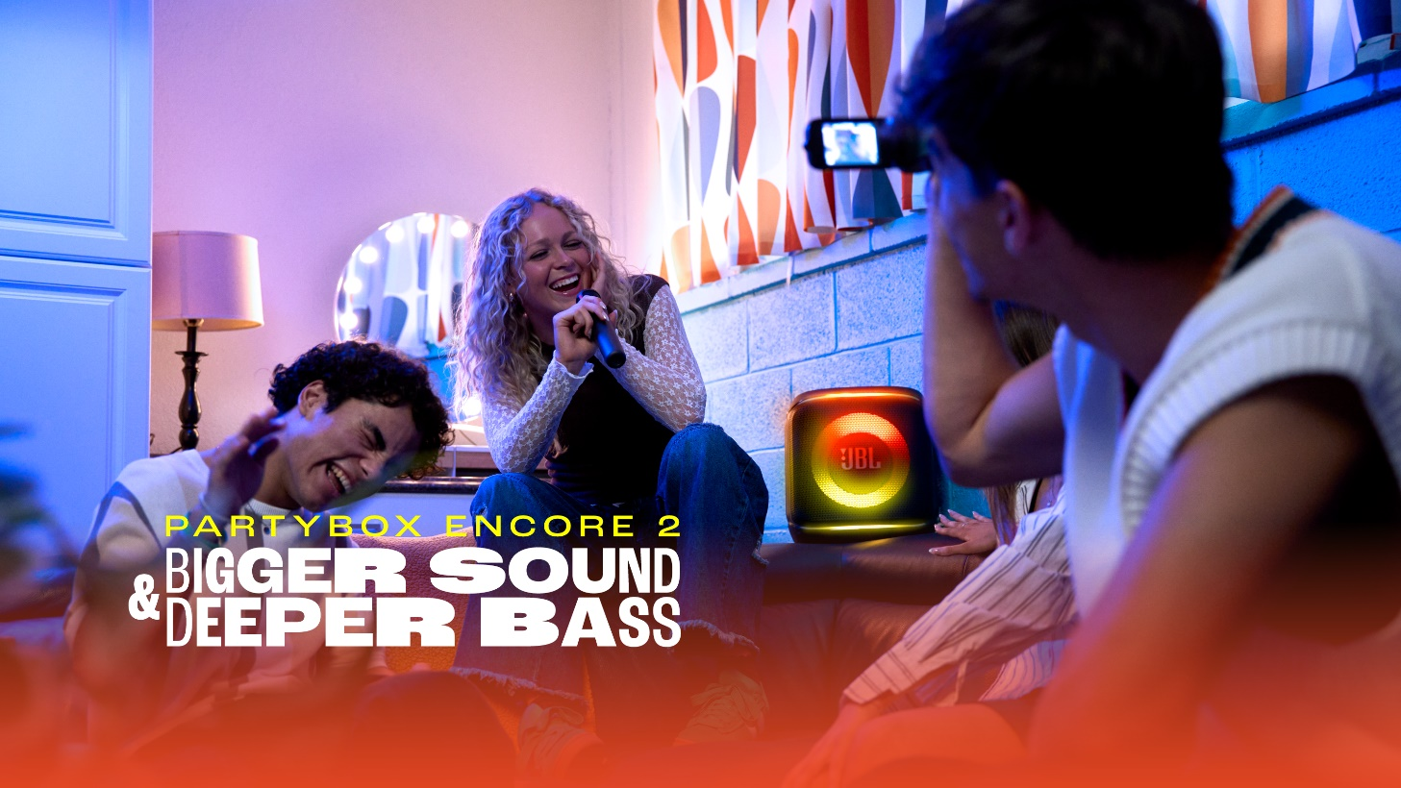
Bigger Sound, deeper bass!

Athens – March 26th 2025. JBL Greece (Official Distributors WaveMotion S.A.) launches the new addition to the Partybox range, the Partybox Encore 2. Powerful sound, immersive light shows and easy multi-speaker connectivity lets you take the party anywhere you want!

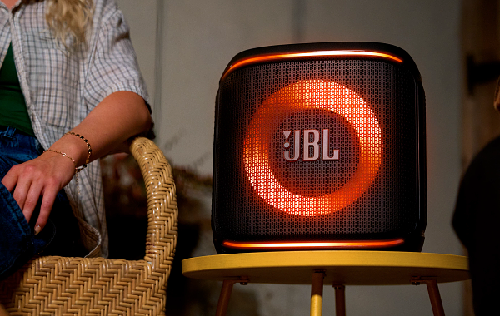
Its new exclusive AI Sound Boost technology, combined with JBL Pro Sound, allows for optimum results with dynamic bass and crystal clear treble, ensuring that music sounds great, whether in the living room or the backyard pool. With the option to add a replaceable battery, the party goes on non-stop for even longer.

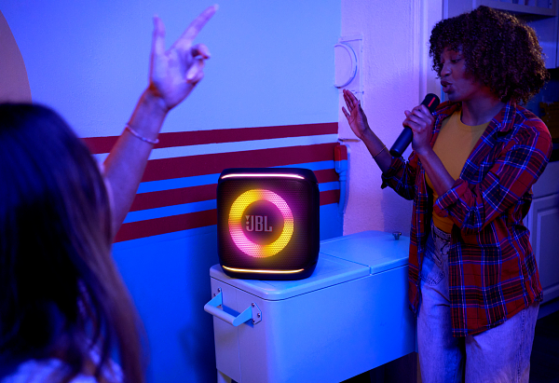
Enable Auracast™ and pair with more JBL speakers at the same time for maximum audio performance. With IPX4 certification, you can listen to your favorite music by the pool or on the beach without fear. Enjoy 15 hours of continuous playback whether it's a party or karaoke night!

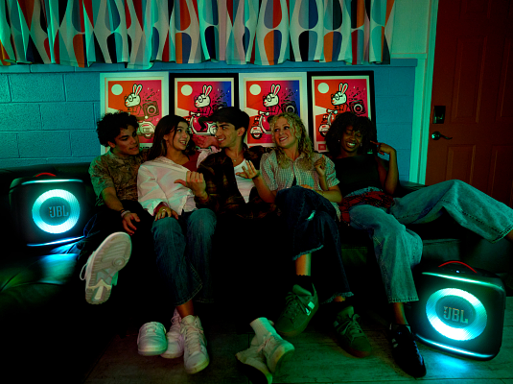
The new Partybox Encore 2 comes with a JBL wireless microphone, which you can store in the special pocket on the back of the speaker for endless nights out and karaoke competitions with your friends! Carry it wherever you want with the built-in handle and start the fun anytime.

Elevate any event with incredible JBL Pro Sound, combined with a spectacular lightshow that changes with your music. Meet the newest member of the JBL Partybox family.

More information on our site Home | JBL (jblgreece.gr)
And our socials Facebook , Instagram, Tiktok

About WaveMotion
WaveMotion, an importer and distributor, is seated in Athens Greece, operating on a wholesale basis, in the consumer electronics, telecommunications and computer industry for over 35 years. WaveMotion S.A. retains the official, exclusive, distribution for the Greek market of important Houses- in leading positions in the Global Arena, like JBL, harman/kardon, Cambridge Audio, Q Acoustics, QED, Goldring, rapoo, Native Union, Livall. Brand Development is the core skill of WaveMotion Team. The vision of our people is to expand WaveMotion’s Brands selection, following our tagline’s principles –Technology, Aesthetics, Design- and continue this journey of Ours, introducing compellingly and establishing decisively these Brands, in the eyes of our Customers.

About HARMAN
HARMAN (harman.com) designs and engineers connected products and solutions for automakers, consumers, and enterprises worldwide, including connected car systems, audio and visual products, enterprise automation solutions; and services supporting the Internet of Things. With leading brands including AKG®, Harman Kardon®, Infinity®, JBL®, Lexicon®, Mark Levinson® and Revel®, HARMAN is admired by audiophiles, musicians and the entertainment venues where they perform around the world. More than 50 million automobiles on the road today are equipped with HARMAN audio and connected car systems. Our software services power billions of mobile devices and systems that are connected, integrated and secure across all platforms, from work and home to car and mobile. HARMAN has a workforce of approximately 30,000 people across the Americas, Europe, and Asia. In March 2017, HARMAN became a wholly-owned subsidiary of Samsung Electronics Co., Ltd..

